

**North South University**

**Project Documentation**

**CSE 427**

Title: Tick-Tac-Toe

**Submitted By:**

|  |  |  |
| --- | --- | --- |
| Muhammad Sakib Khan | 1520016042 | muhammad.sakib@norhsouth.edu |

**Submitted to:**

**Shaikh Shawon Arefin Shimon**

Lecturer,

Department of Electrical and Computer Engineering

North South University

# 

**Graph Coverage**

**Class – GameEngine.java**

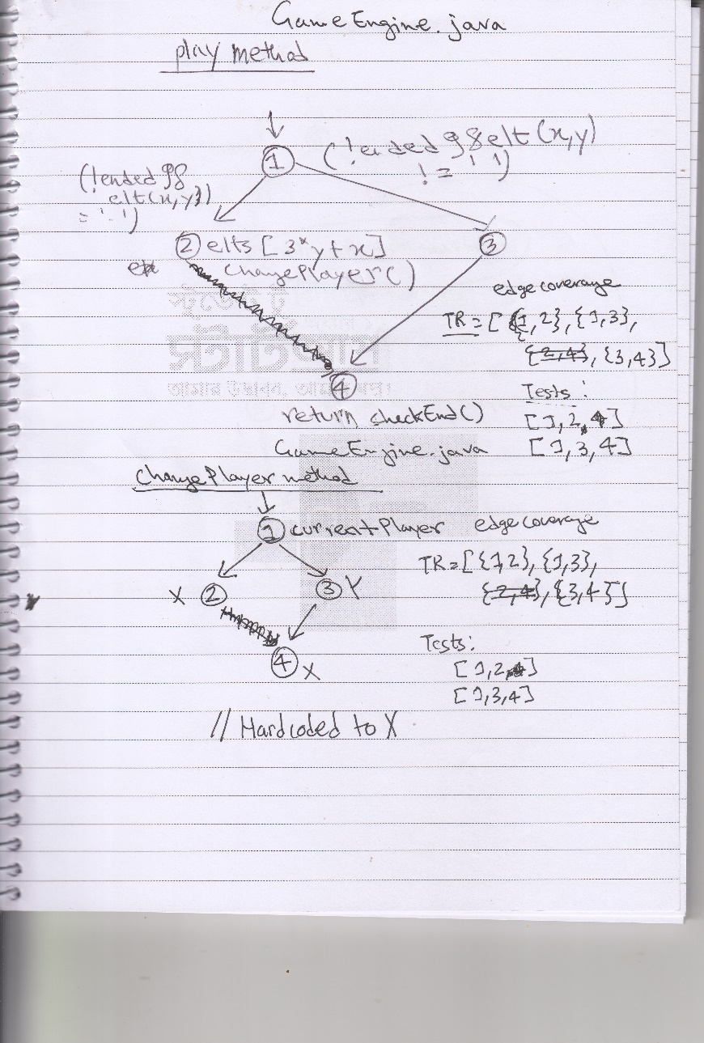

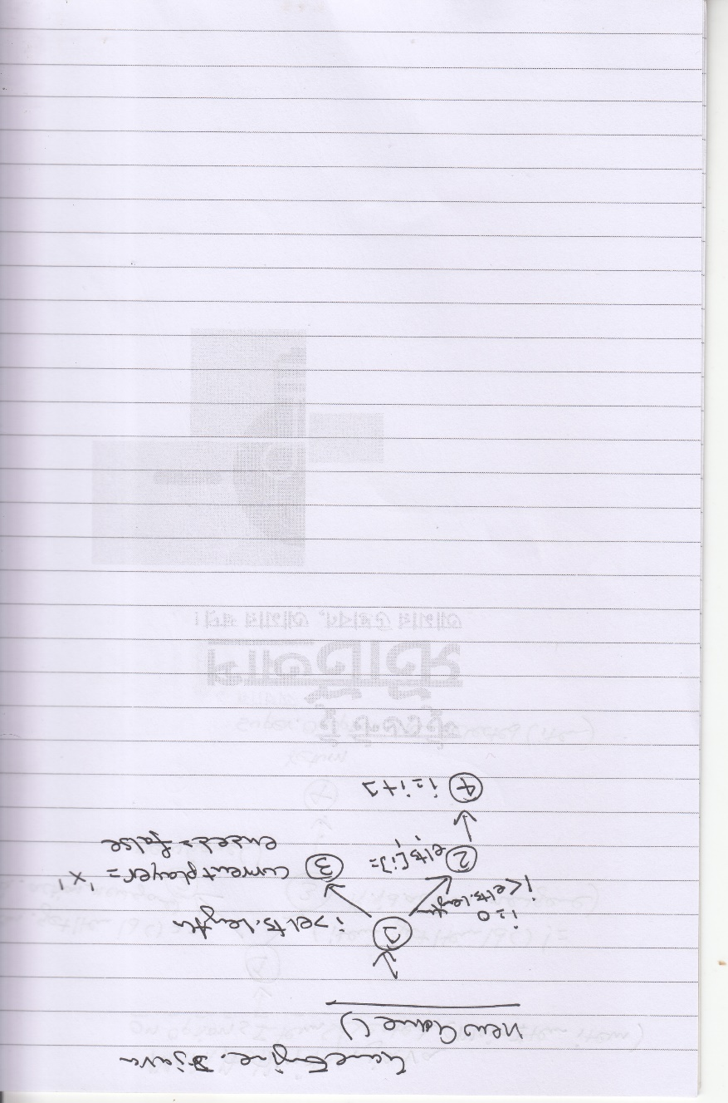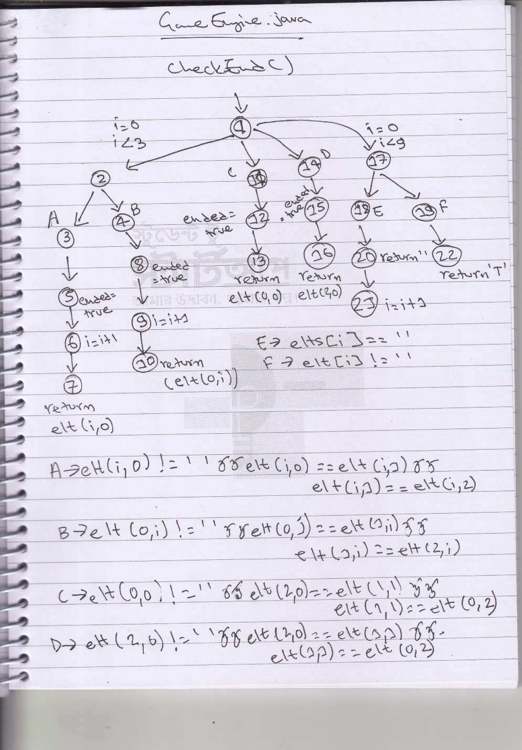

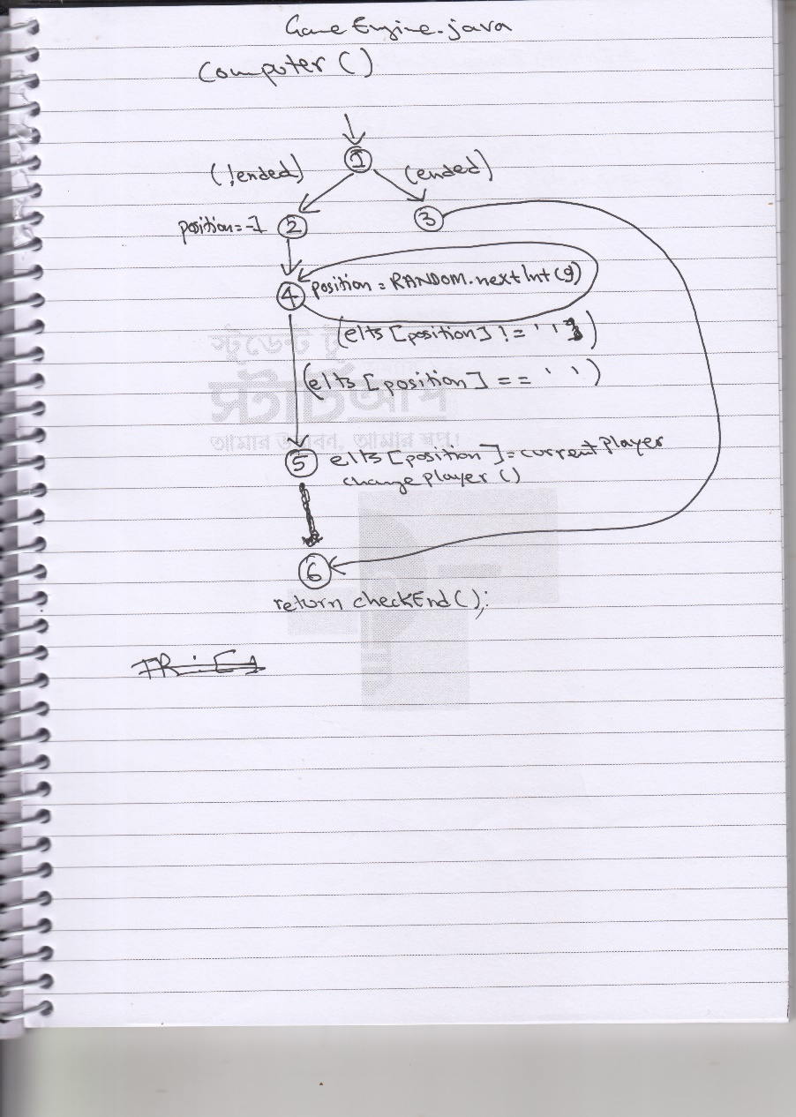

**Class – MainActivity.java** 